

- Go to the Firewall Access Rule Menu and click “Add…” to add a newRule
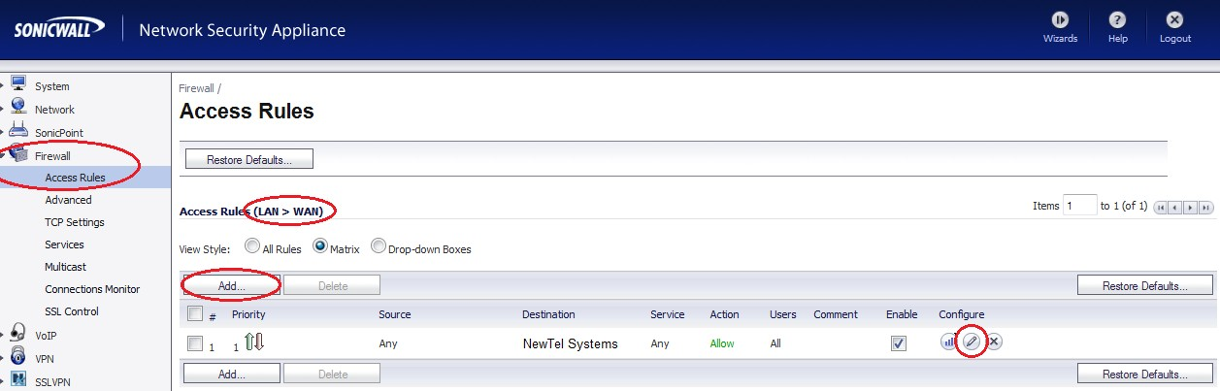

- 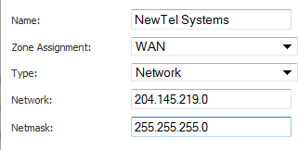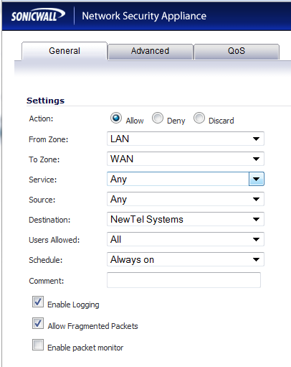Create a LAN -> WAN Rule. (Figure1)
** NO WAN -> LAN RULES ARE NEEDED**
Figure 2

- Create a new Address Object in the “Destination” selector. (As displayed in Figure2)
- Switch to the “Advanced“ tab of the new Accessrule.
- Modify the “UDP Connection Inactivity Timeout” and set it to 60 or above (preferably 120). The current setting of 30 is inadequately low and will cause the firewall NAT hole to close premature to our 50 second keepalive packets refreshing the NAT session. (See Figure 3 for reference)
- You may choose to apply the DSCP and 802.1p QoS settings in the “QoS” tab. (As displayed in Figure4)
- Save the new Access Rule and ensure it appears above any other catch-all or conflictingrules.
- To ensure the voice traffic is now flowing through the new rule you created, move your mouseovertheicon. You do not have to click on it. If you configured and prioritized the rule correctly (and the phones are plugged in) you should see some trafficincrementing.
- Ensure that under the “VoIP Settings” tab Consistent NAT is ENABLED and SIP Transformations are DISABLED. (As displayed in Figure 5). Phones should be rebooted if they were connected prior to disabling SIP Transformations.

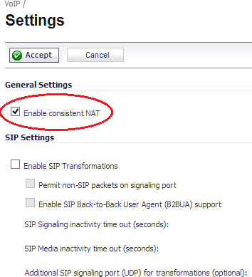Figure 1

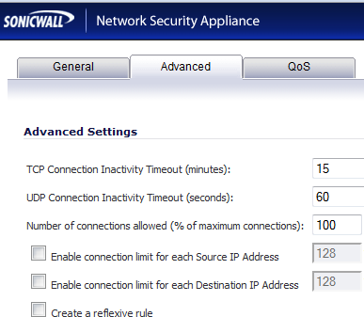
Figure3

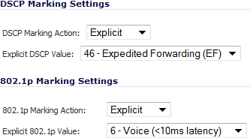
Figure4

Figure 5

If you feel that you do not want to perform the above steps and prefer a simpler method. You may change the default “UDP Connection Inactivity Timeout” for the entire firewall as opposed to only voice traffic to TALKandTEL. You would find this setting under the FIREWALL -> ADVANCED menu. This method is much simpler and perfectly secure. You must ensure that there is no default catch-all (ANY to ANY) LAN -> WAN rule that overrides this setting.

